



FACULTY OF ENGINEERING AND IT
COMPUTER SYSTEMS ENGINEERING DEPARTMENT
Embedded Systems Lab Report
Experimet(4) : Keypad board
Date: 30/11/2022

Student Name: | Suha Alardah, Dalya Alawneh, Wafa' Abd Alhadi
Student ID: | 201811033 , 201810937 , 201810726
Experiment Name: | Keypad board
Experiment No.: | 4
Instructor Name: | Dr. Mujahed Eleyat
Supervisor Name: | Mr. Hussein Younis
Section: | 3
Partner Name if any:

Objectives
- Learn about the components of the keypad and the principle of its work.
- Know how to connect the keyboard with the LED and control it.
- The mechanism to find out which button to pressed and to know the two methods is
either to be :
- scanned and requires in this process that the CPU is on
- or by interrupt, which is called poling. When pressed, interrupt occurs.

Introduction
The main objective of this experiment is to teach the participants the keypad and how to connect it to the PIC184550 and connect it with the LEDs.
This experiment teaches us about the keypad board, which is made up of horizontally and vertically entwined wires that link when the button is pressed. The first three bits are for columns, while the last four bits are for rows.

Components Required:
ID | Component name | Amount
1 | Led board | 1
2 | Board kit inside it Pic 18F4550 | 1
3 | Keypad board | 1
4 | Pc | 1
5 | PIC Programmer and software tools  Programming PIC Microcontrollers with MPLAB and Loader requires loading the code into the ROM of the PIC. | 1
7 | Wires &Powered Caple | 3 &1

Tasks
- Keypad + LED
  - Key1: LEDs are ON
  - Key4: LEDs are OFF
  - Key7: LEDs blink every 0.25 seconds for 2 seconds
- Keypad + LED
  - *: TURN ON all LEDs
  - #: TURN OFF all LEDs
  - 1: TURN ON the first LED
  - 2: TURN ON the second LED
  - .
  - .
  - 8: TURN ON the 8th LED
- Solve task 2 using interrupts

Flowchart (USE any diagram app like diagrams.net )
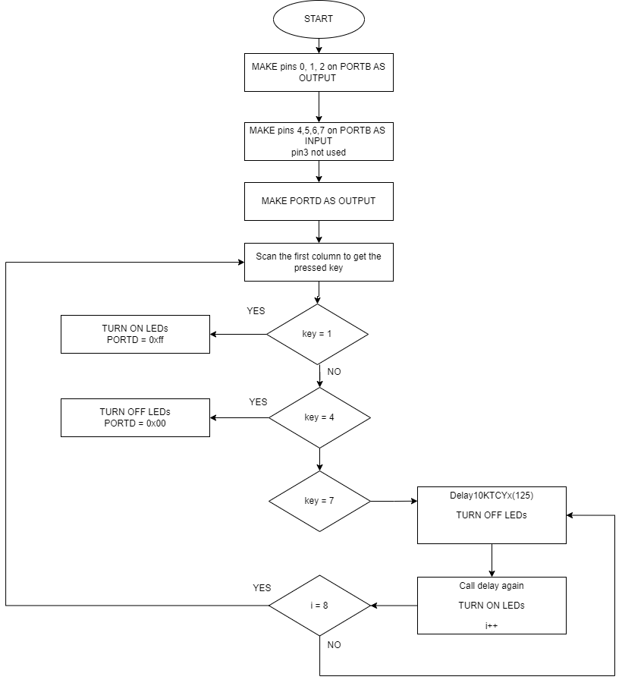
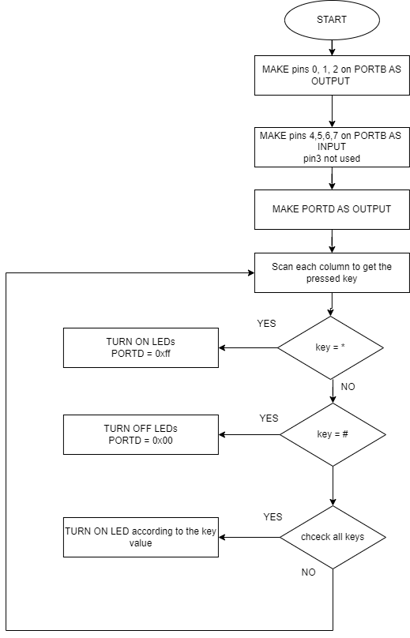

Codes

Task 1
int scan(){
int key;
PORTBbits.RB0 = 1;
PORTBbits.RB1 = 0;
PORTBbits.RB2 = 0;
if(PORTBbits.RB4 == 1){
key = 1;
}else if(PORTBbits.RB5 == 1){
key = 4;
}else if(PORTBbits.RB6 == 1){
key =7;
}
return key ;
}
void main()
{
int i =0;
//*********** Code Part ***********
TRISD = 0;
PORTD = 0;
TRISBbits.TRISB0 =0;
TRISBbits.TRISB1 =0;
TRISBbits.TRISB2 =0;
TRISBbits.TRISB4 =1;
TRISBbits.TRISB5 =1;
TRISBbits.TRISB6 =1;
TRISBbits.TRISB7 =1;
if(scan() == 1){
PORTD = 0xff;
}else if(scan() == 4){
PORTD=0;
}else if(scan() == 7){
while(i!=8){
Delay10KTCYx(125);
PORTD = 0;
Delay10KTCYx(125);
PORTD = 0xff;
i++;
}
}
}

Task 2
unsigned char scan3(){
unsigned char key;
PORTBbits.RB0 = 0;
PORTBbits.RB1 = 0;

PORTBbits.RB2 = 1;
if(PORTBbits.RB2 = 1){
if(PORTBbits.RB4 == 1){
Delay10TCYx(20);
key = '3';
}else if(PORTBbits.RB5 == 1){
key = '6';
}else if(PORTBbits.RB6 == 1){
key ='9';
}else if(PORTBbits.RB7 == 1){
key ='#';
}
}
return key ;
}
unsigned char scan2(){
unsigned char key;
PORTBbits.RB0 = 0;
PORTBbits.RB1 = 1;

PORTBbits.RB2 = 0;
if(PORTBbits.RB1 = 1){
Delay10TCYx(20);
if(PORTBbits.RB4 == 1){
key = '2';
}else if(PORTBbits.RB5 == 1){
key = '5';
}else if(PORTBbits.RB6 == 1){
key ='8';
}else if(PORTBbits.RB7 == 1){
key ='0';
}
}

return key ;
}
unsigned char scan(){
unsigned char key;
PORTBbits.RB0 = 1;
PORTBbits.RB1 = 0;
PORTBbits.RB2 = 0;
if(PORTBbits.RB0 = 1){
Delay10TCYx(20);
if(PORTBbits.RB4 == 1){
key = '1';
}else if(PORTBbits.RB5 == 1){
key = '4';
}else if(PORTBbits.RB6 == 1){
key ='7';
}else if(PORTBbits.RB7 == 1){
key ='*';
}
}
return key ;
}
void main()
{
int i =0;
//*********** Code Part ***********
TRISD = 0;
PORTD = 0x00;
TRISBbits.TRISB0 =0;
TRISBbits.TRISB1 =0;
TRISBbits.TRISB2 =0;
TRISBbits.TRISB4 =1;
TRISBbits.TRISB5 =1;
TRISBbits.TRISB6 =1;
TRISBbits.TRISB7 =1;
if(scan() =='*'){
PORTD = 0xff;
} if(scan3() == '#'){
PORTD=0x00;
Delay10TCYx(20);
}if(scan() == '1'){
PORTDbits.RD0 = 1;
Delay10TCYx(20);
}
if(scan2() == '2'){
PORTDbits.RD1= 1;
Delay10TCYx(20);
}if(scan3() == '3'){
PORTDbits.RD2= 1;
Delay10TCYx(20);
}if(scan() == '4'){
PORTDbits.RD3= 1;
Delay10TCYx(20);
}if(scan2() == '5'){
PORTDbits.RD4= 1;
Delay10TCYx(20);
}if(scan3() == '6'){
PORTDbits.RD5= 1;
Delay10TCYx(20);
}if(scan() == '7'){
PORTDbits.RD6= 1;
Delay10TCYx(20);
}if(scan2() == '8'){
PORTDbits.RD7= 1;
Delay10TCYx(20);
}
}

task3
void chk_isr(void);
unsigned char scan();
unsigned char scan2();
unsigned char scan3();
#pragma interrupt chk_isr
void chk_isr (void)
{
if(INTCONbits.INT0IF){
INTCONbits.INT0IF = 0;
if(scan() == '1'){
PORTDbits.RD0 = 1;
Delay10TCYx(20);
}
if(scan() == '4'){
PORTDbits.RD3= 1;
Delay10TCYx(20);
}
if(scan() == '7'){
PORTDbits.RD6= 1;
Delay10TCYx(20);
}if(scan() =='*'){
PORTD = 0xff;
Delay10TCYx(20);
}
Delay10TCYx(20);
}if(INTCONbits.INT1IF){
INTCONbits.INT1IF = 0;
if(scan2() == '2'){
PORTDbits.RD1= 1;
Delay10TCYx(20);
}
if(scan2() == '5'){
PORTDbits.RD4= 1;
Delay10TCYx(20);
}
if(scan2() == '8'){
PORTDbits.RD7= 1;
Delay10TCYx(20);
}
}if(INTCONbits.INT2IF){
INTCONbits.INT2IF = 0;

if(scan3() == '3'){
PORTDbits.RD2= 1;
Delay10TCYx(20);
}
if(scan3() == '6'){
PORTDbits.RD5= 1;
Delay10TCYx(20);
}
if(scan3() == '#'){
PORTD=0x00;
Delay10TCYx(20);
}
}
void main()
{
int i =0;
//*********** Code Part ***********
TRISD = 0;
PORTD = 0x00;
TRISBbits.TRISB0 =1;
TRISBbits.TRISB1 =1;
TRISBbits.TRISB2 =1;
TRISBbits.TRISB4 =0;
TRISBbits.TRISB5 =0;
TRISBbits.TRISB6 =0;
TRISBbits.TRISB7 =0;
INTCONbits.INT0E = 1;
INTCONbits.INT1E = 1;
INTCONbits.INT2E = 1;
INTCONbits.PEIE = 1;
INTCONbits.GIE = 1;
INTCON2bits.INTEDG0 = 1;
INTCON2bits.INTEDG1 = 1;
INTCON2bits.INTEDG2 = 1;
INTCONbits.INT0IF = 0;
INTCONbits.INT1IF = 0;
INTCONbits.INT2IF = 0;
while(1);
return;
}
unsigned char scan2(){
unsigned char key;
PORTBbits.RB0 = 0;
PORTBbits.RB1 = 1;
PORTBbits.RB2 = 0;
if(PORTBbits.RB1 = 1){
Delay10TCYx(20);
if(PORTBbits.RB4 == 1){
key = '2';
}else if(PORTBbits.RB5 == 1){
key = '5';
}else if(PORTBbits.RB6 == 1){
key ='8';
}else if(PORTBbits.RB7 == 1){
key ='0';
}
}
return key ;
}
unsigned char scan(){
unsigned char key;
PORTBbits.RB0 = 1;
PORTBbits.RB1 = 0;
PORTBbits.RB2 = 0;
if(PORTBbits.RB0 = 1){
Delay10TCYx(20);
if(PORTBbits.RB4 == 1){
key = '1';
}else if(PORTBbits.RB5 == 1){
key = '4';
}else if(PORTBbits.RB6 == 1){
key ='7';
}else if(PORTBbits.RB7 == 1){
key ='*';
}
}
return key ;
}

unsigned char scan3(){
unsigned char key;
PORTBbits.RB0 = 0;
PORTBbits.RB1 = 0;

PORTBbits.RB2 = 1;
if(PORTBbits.RB2 = 1){
if(PORTBbits.RB4 == 1){
Delay10TCYx(20);
key = '3';
}else if(PORTBbits.RB5 == 1){
key = '6';
}else if(PORTBbits.RB6 == 1){
key ='9';
}else if(PORTBbits.RB7 == 1){
key ='#';
}
}

return key ;
}

Procedures
- For the first task we start with making columns output and rows as input, then scan only the first column to get the pressed key then check the value if equal 1 TURN on LEDs which are connected with PORTD and so on for 4, and 7.
- For the second task we have to scan all columns to get the key after that check the value to TURN on the appropriate LED.
- For the last task we want to use interrupt with task 2, first we need to enable an interrupt for each column and check the interrupt flag in Interrupt service routine when a row change from 0 to 1 scan it to get the key.

Discussions and Conclusions
We discover more about what can be connected with the PIC 18, how to connect the cables with it, and how to control the LED lights, which was like a beautiful game. We had a problem in setting the appropriate delay when moving from pole to pole, but it was solved with the help

